Ideation Phase
Define the Problem Statements

Date | 29-11-2025
Team ID
Project Name | DocSpot- Doctor Appointing Booking System
Maximum Marks | 2 Marks

Problem Statement Table:

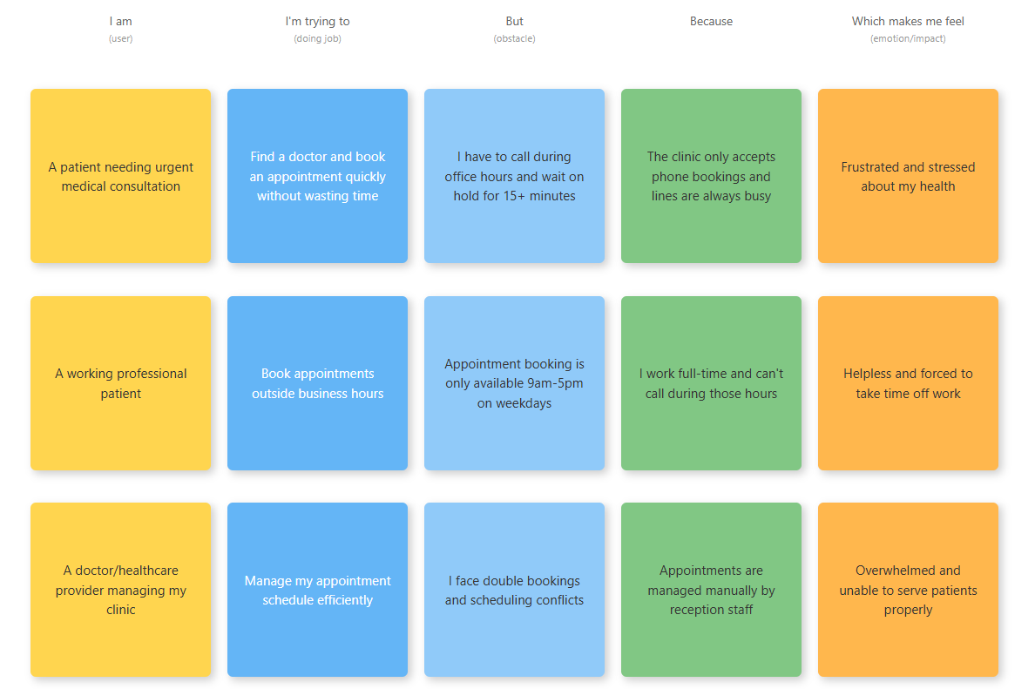

Problem Statement (PS) | I am (Customer) | I’m trying to | But | Because | Which makes me feel
PS-1 | Patient needing medical consultation | Book an appointment with a doctor quickly | I have to call during office hours and wait on hold for 15+ minutes | The clinic only accepts phone bookings and lines are always busy | Frustrated and stressed about my health
PS-2 | Working professional patient | Book appointments outside business hours | Appointment booking is only available 9am-5pm on weekdays | I work full-time and can't call during those hours | Helpless and forced to take time off work
PS-3 | Doctor/Healthcare provider | Manage my appointment schedule efficiently | I face double bookings and scheduling conflicts | Appointments are managed manually by reception staff | Overwhelmed and unable to serve patients properly

